Preliminary Convention
for formation of
All India Casual Workers Association
of
Income Tax Department
Organised by: Central JCA, Income Tax Department
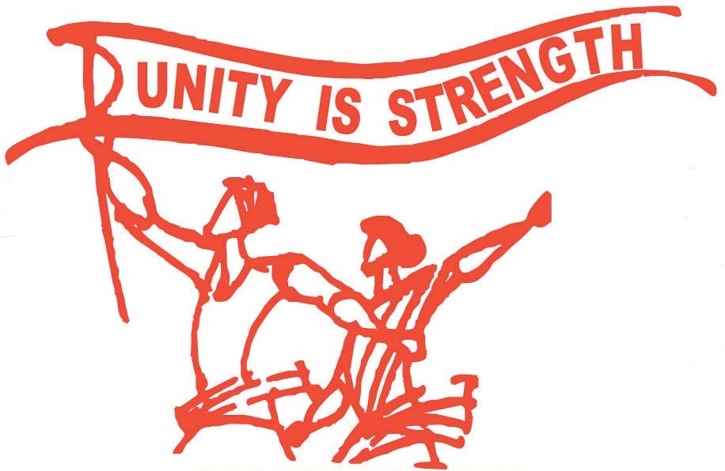
Venue
Multipurpose Hall
Aayakar Bhawan
P-7 Chowringhee Square
Kolkata-700069

Date: 14th August 2017 Time:10 A.M
Host
Income Tax Casual Workers Association, West Bengal In Association with JCA, W.B
Make the CONVENTION a GRAND Success

PROGRAMME
14.08.2017 at 10 AM Inauguration
Garlanding in the memory of Martyrs
Opening Songs
Welcome the Dignitaries/JCA Leaderships on the Dias & Felicitation
Deliberation by Com. Mrinal Chanda, Chairman, Reception Committee
Inauguration Speech by Com. K K N Kutty, President, Confederation of CGEW
Speech by Com. Ashok Kr. Kanojia, President, ITEF
Speech by Com. Pradip Roy, President, Non-regular Co-ordination Committee
of West Bengal
Speech by Com.Debnath Mukherjee, Chief Advisor, I Tax Casual Workers’ Assc.WB Speech by Com. Bhaskar Bhattacharya/Rupak Sarkar, Jt.Convenors, Central JCA
Lunch at 1.30 PM
Deliberation of Delegates
Finalisation of Constitution
Finalisation of Resolution on Demands
Selection of Preparatory Committee of All India Casual Workers’ Association

Vote of Thanks by Com. Mridul Mukherjee, General Secretary,
Income Tax Casual Workers Association, West Bengal

